EWHT – Vendor DP & Clg

- Create DP request using T Code F-47
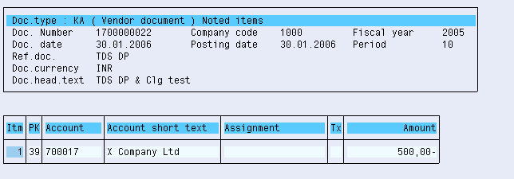

- Payment to Vendor using T Code f-48
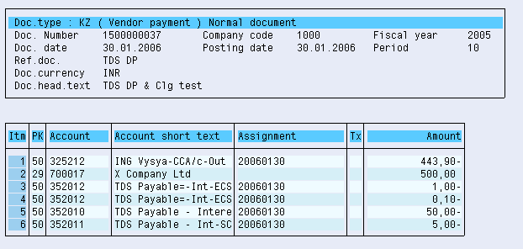

- Book Vendor invoice using T Code FB60
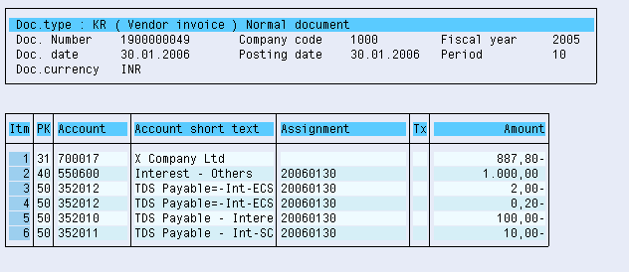

- Clear Vendor Invoice against the Down Payment

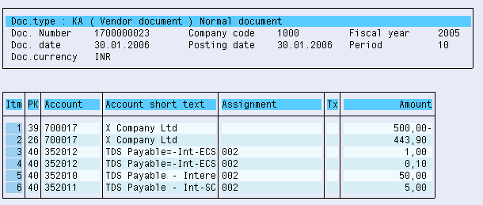

 Clear Invoices Against Down Payments

Use
If you withhold tax on a vendor down payment, and the vendor then sends you an invoice, you have to clear the withholding tax when you have entered the invoice (not when you pay the invoice, as is customary in other countries).

Features
This function has been incorporated into the standard function for clearing down payments (see Clearing). When you clear an invoice against a down payment for an Indian company code, the system clears the withholding tax automatically, if the company code is located in India.

Activities

Customizing
In order for the tax to be cleared correctly, you must post the down payments using:
• A withholding tax type that is marked as Central Inv. Prop. (Central invoice proportionate)
• A withholding tax code that uses the posting indicator 1 (Standard posting: bank/vendor/customer line item reduced)
If you use either of the other two methods, the adjustment will be made against the offsetting account instead of the vendor account.

Day-to-Day Activities
Make sure that the withholding tax codes you use when you enter the down payment and the invoice are assigned to the same withholding tax key, otherwise the clearing program will not let you clear them.
Once you have posted the vendor invoice, clear the down payment against it. To access the function, on the SAP Easy Access screen, choose Accounting → Financial Accounting → Accounts Payable → Document Entry → Down Payment → Clearing.
 Example
A vendor provides you with some services, for which it promises to send you an invoice in a few days' time.
In the meantime, you make a down payment on the services for a total of INR 10,000, presenting the vendor with a check for INR 9,796 and withholding the remaining INR 204 as tax:
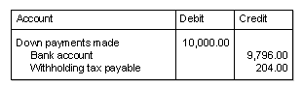
A week later, the vendor sends you the invoice, for a total of INR 20,000 – on which you have to withhold a total of INR 408. You post the invoice as normal, which gives the following accounting document:
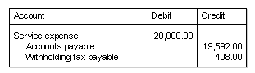
You then clear the invoice against the down payment. The system takes into account the INR 204 of tax that you have already withheld, and creates the following accounting document to clear the down payment against the invoice, and clear the withholding tax account:
